Object Diagram

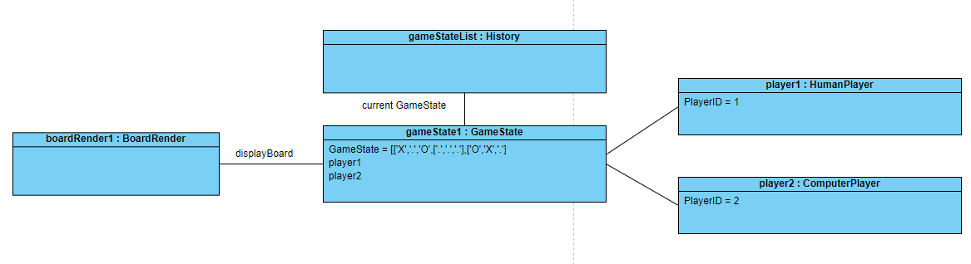

sequence diagram

